# **Wed [01/18/2023]: Intro**

* The room is *circular*
* Watch films/readings done BEFORE recitations on Wednesdays
* Tom if you are reading this sit as close to the left of professor as possible to avoid the *name game*

# **Fri [01/20/2023]: First Lecture**

* Rest in peace David Crosby and Woodstock
* Film is a difficult thing to study b/c of preconceived bias and b/c of how common film is in casual day-to-day life
* Film also involves multiple art forms (ie music, architecture, fashion, etc) which can make studying and analyzing films difficult
* Film involves sometimes unusual vocab that may be new to many, but said vocab is used to strengthen understanding of film (i.e. “mise en scene” -> everything on screen)
* Need to learn film vocab and engaging critically with the language of the film to “think” film rather than just “watch” film
* Disney’s TANGLED is the most expensive movie per frame all time ($1806/frame)
* THREE DOMINANT APPROACHES:
  + Evolutionary (Technological)
  + Masters and Masterworks (Individuals)
  + Periodization (Socio-Cultural)
* Towards a synthetic approach
  + Film as Creative and Productive Practice
  + Film and History together
* Film Theory Boot Camp:
  + Preproduction = Development hell, sourcing material, writings, actors, everything BEFORE filming
  + Production = The process of making a film that includes editing, filming, etc
  + Post Production = Editing, sound design, scoring
  + Distribution = How the movie gets to the audience once completed. Includes Domestic Theatrical releases, ancillary markets (planes, schools, etc), and international markets
* Realism vs Expressionism:
  + Realism = Film attempting to portray things as realistically as possible
  + Expressionism = Artistic interpretation of an element or scene (ie the Bear Attack in The Revenant taking place in a more cinematic location than real life’s mundane location)

# **Wed [01/25/2023]: Second Recitation**

* The 4 Strata of Meaning
  + Referential: Comprehension of the material (ie seeing Empire State Building = in NYC)
  + Explicit: Meaning that the film was “going for” (what film tells you it means explicitly)
  + Implicit: The “theme” of the movie that may or may not be explicitly stated (i.e. a theme in Wizard of Oz is ‘friendship’ even if not stated in the film)
  + Symptomatic: Potentially unintentional themes/meanings, reading ‘against’ the text
* Hhhheeewwwwwooooooo OwO
* Huh? A Dockwurkuh? That is soooo interwesting -u- *3* ^v^
* UwU UwU UwU UwU a dockworker in Hoboken; the union is corrupt.
* **John**ny Friendly (Bad guy)
* **John**ny Friendly (confirmed communist, possible gay furry (need to follow up))

# **Fri [01/27/2023]: Second Lecture**

* Early Cinema
  + Context of Early 1900s US Before Film
    - America transitioned from era of “wild west” to more urbanized/settled
    - High immigration, industrialization, commercialized
    - Increase in democracy’s reach/effectiveness
    - Frontiers closed around turn of 20th century (1900s)
    - Literacy has generally gone up (good for cinema)
  + Evolution
    - Cinema Obscura = Pinhole camera that projected upside-down image
    - Shadow Play = ie the Allegory of the Cave
    - Magic Lantern = the flip-slide toys
    - Zoetrope = the animated image flip-book that could rotate images quickly\
    - MTA Masstransiscope = “I ain’t never seen that shit before” (train flip-book) in Brookland
  + Kinetoscope
    - Developed by Edison and William Dickson
    - Perforated Film (George Eastman)
    - Individual Experience
    - Edison’s Black Maria Facility
  + Cinematograph
    - Sold by Bouly to the Lumiere brothers
    - Portable and hand-cranked
    - Projectable so easily distributable and can be show to audiences instead of individuals
  + Stage vs Photography
    - Stage
      * Mise-en-scene
      * Performance
      * Audience Relationship
    - Photography
      * Invisibility (don’t want focus to be on a camera)
      * Action/Stillness
      * Image

# **Wed [02/01/2023]: Third Recitation: Narrative Pressure**

* Cinema as a Storytelling Medium:
  + Cinema of Attractions
    - Mostly showcased the technology as a novelty
    - Characterized by short slideshows basically used as an exhibition in early 1900s
  + Media Entertainment = Competitors to Films
    - Stage Shows (ie Vaudeville, Traditional Theater, Wild West Shows, etc)
    - Written Stories (like books and newspapers)
    - Visual Arts (paintings, photography)
    - Other Entertainment (sports, circuses, penny arcades, etc)
  + Chatman’s “What Novels Can do that Films can’t and Vice Versa”
    - Assertion vs Description
    - Counterpoint: *Vertigo* which utilized establishing shots and action to convey meanings
  + Eventual Transition of Cinema from “Cinema of Attractions” to Storytelling Medium
    - Increased complexity and length thanks to better technology
* Birth of the Industry
  + Pressures:
    - Narrative Pressure (audiences craved narratives)
    - Social Pressures (the morality police)
    - Artistic Aspirations/Pressures of industry members (desire to show Cinema can be big)
  + Organization
    - Vertical Integration (buying every step of production and doing everything “in house”
    - Economies of scale, leading to cutbacks creatively and more conservative works
  + Cultural Changes:
    - Moral Panic = Censorship
    - Demographics Changing = Americanization
    - Geopolitical Uncertainty = Hegemonic Tool (propaganda)
    - Class Conflicts = Wish Fulfillment (selling “dreams”)
* Towards a synthetic approach
* Production Code - Used by early Hollywood where any film had to meet approval by PC office; assessed violence, etc. (Was it family friendly? Proper censorship?)
* Discourse time vs. Story time (Talking about cman essay)
* Novels can assert details and/or show details, but films can (typically) only show details (to assert means giving ideas through description like the HEIGHT of someone being 5’6” which is the best height btw, vs on-screen, literally showing the shit happening)

# **Fri [02/03/2023]: Fourth Recitation: Bringing Hollywood Up to Code**

* Early Hollywood
  + Film industry moves away from NJ to California
    - Better weather/climate and generally sunnier
    - More opportunities for space/scale/everything
    - Escaping East’s Patent fights
      * Dickson/Biograph v Edison
        + Edison loses, opens floodgates for foreign markets which Edison cracks down on by forming **Edison Trust**
      * Edison creates licensing agreements and trusts to control key technology to stymie the market
      * Production Quality overall increases
      * But creativity is restricted in favor of making safer profits
      * Edison’s trust strictly enforced against Independent Operators
      * Edison’s Trust eventually loses control 1911 - 1918 with WW1 and expiring patents
    - California’s friendlier legal jurisdiction meant more freedom for filmmakers
    - Outlet to Mexican markets as well
    - 1910 first film shot in California (D.W. Griffith)
    - 1911 First Movie Studio established in Hollywood (Nestor, originally from Bayonne)
    - 1914 First Hollywood Feature-Film: *The Squaw Man*
  + Establishment of Hollywood increased demand for higher quality films
    - More domestic and global competition, dissatisfaction with “Cinema of Attractions” since technology has now been around for awhile and expectations were growing
    - Hollywood poaching talent from theater, etc (establishment of Stars System)
  + Hollywood’s Foreign Competition
    - *Cabiria* by Giovanni Pastrone (1914)
      * Noted for grandiose scale and inventing the “tracking shot”
* Pioneers of Hollywood
* The Production Code
  + Industry of Filmmaking creates office for self-sensor of content for “public decency”
* Cinema of Attractions - term coined by
  + Era of film where the primacy of the image was paramount
  + Fascinated by moving pictures, so celebration of technology and “the spectacular” rather than emphasis on telling gripping stories
* Major Competitors to Early Film
  + Theater/Traditional Stage Play, Vaudeville, Books, Journalism

# **Tue [02/07/2023]: Scarface and Baby Face**

* Scarface:
  + Shocking that THIS needed censorship - that message at the beginning
  + Comical action
  + Relaxing? Compared to modern 3-second shots
  + High budget - cars
  + Car driving scenes - really good, better than 90s!
  + plot/acting significantly better than older things
  + Comic relief with the secretary
  + Whistle noisy song when he kills
  + Version A, was viewed by the AMPP on 8 Sep 1931, at which time the AMPP told Hughes that the ending must be altered in order to negate the heroism of "Camonte."
  + Some of the deletions included a scene in which "Camonte" embraces his sister "Cesca" after he has slapped her; a scene on "Camonte's" yacht; and a scene in which "Camonte" purchases a gift for his mother.
  + Hanging of Tony Comonte at the end - with a double in NY
* Babyface:
  + Will Power
  + The Will to Power
  + Last guy
  + Shot of the side of the building, rising up

# **Fri [02/10/2023]: The Industry Code**

* To Watch:
  + Royal Tenenbaums
  + Meet Me in St. Louis
* To Read:
  + Film Art Module in Mise-en-scene
  + Style in Microcosm
* Transition of Cinema as a Medium
  + Cinema of Attractions to Cinema of Narratives
    - Novelty of medium wore off and expectations grew
* The Edison Trust
  + Controlled length, content, cost etc of movies to maintain control of industry
  + Increased quality of films as way of competition since trust fixed prices
    - Still limiting in content and length of films
    - Based purely on Edison’s personal assessments
* California v NJ
  + California overall better range of climates/areas that have space and are accessible
* D.W. Griffith = “Father of Films”
  + Extreme Racist
  + Directed Birth of a Nation and Life of General Villa
* Cecil B. DeMille = “Father of Hollywood”
  + The Squaw Man, The Ten Commandments, etc

# **Fri [03/03/2023]: Hollywood’s Golden Age**

* Upcoming MIDTERM EXAM:
  + Blue Book Exam (provided paper-pencil)
  + Will have 2 essays (1 about history of film (ie move west, narrative pressure, etc) and 1 about comparing two movies)
* Movies to Watch: Citizen Kane and Vertigo
* Production System >> Product
  + Mass production vs Small Batch
  + Franchises vs Independent Operators
* Hollywood’s Studio System:
  + Vertical Integration (Owning every sector of the industry (cinemas, production, filming, etc)
  + Economies of Scale
  + The “Star” System
  + A/B Films: Block Booking
* Studio Characteristics
  + Self-regulation
  + Risk Aversion
  + Narratives:
    - Clear Protagonists and Antagonists
    - Psychological Motives (Desire)
    - Not Social Motives
    - Cause-Effect Train
* Vertigo:
  + 1968 Film Critic Robin Wood
  + 1975 Laura Mulvey “Visual Pleasure in Narrative Cinema” (The Male Gaze)
  + 1983 Re-Released after Hitchcock’s death

# **Fri [03/10/2023]: The #Blacklists of Hollywood**

* Hollywood’s Red Scare
  + Movies to Watch:
    - On the Waterfront
    - High Noon
  + Historical Context:
    - Factionalism and fractures on the political left of the US
      * Socialism and geopolitics
        + 1917 Bolshevik Revolution in USSR
      * Anti-Semitism
      * Growing influence of film on US media/culture
      * Post-WWII American values being reborn
        + Ie Civil Rights movement, inner look at society
    - Labor Organization and Unrest
      * Disney’s Animators’ Strike
      * Tenney Committee (California State Legislature)
      * Motion Picture Alliance for the Preservation of American Ideals
      * Billy Wilkerson / *The Hollywood Reporter*
    - October 1947: Hearings on Hollywood
      * Motion Picture Alliance for the Preservation of American Ideals
      * Committee for the First Amendment
        + Sterling Hayden
      * The “Hollywood 10”
        + Called to testify in Congress at House of Unamerican Activities
        + Alvah Bessie, Herbert Biberman, Lester Cole, Edward Dmytryk, Ring Lardner Jr., John Howard Lawson, Albert Maltz, Samuel Ornitz, Adrian Scott, Dalton Trumbo
      * Industry Response:
        + “Waldorf Statement”

Blacklisted all 10 members from working in industry

* + - * + Increased Scrutiny between 1947 - 1950
      * HUAC II Electric Boogaloo
        + 1951: More hearings on Hollywood and the entertainment industry
        + Legal Strategy: Employ 5th Amendment instead of 1st

Avoided contempt charges and not have to name names

Guaranteed spot on blacklist unfortunately

* + - * + Chilling Effect
        + Sound and Fury, Signifying Nothing
      * Breaking HUAC
        + Joseph McCarthy (aka McCarthyism)
        + Power of Studio System begins to decline following fall of McCarthy
        + Key Events:

1957 Hitchcock hires “greylisted” Norman Lloyd as a consultant for his TV show

*Spartacus*

Self-published by blacklisted author Howard Fast in 1951

Dalton Trumbo (one of Hollywood 10) gets screen credit at insistence of Kirk Douglas

JFK screens film

John Henry Faulk against the publishers of *Counterattack*

* + - * Epilogue
        + 1950 Hollywood 10 begins serving prison sentence
        + J. Parnell Thomas, NJ member of HUAC, arrested for corruption and bribery charges
      * *High Noon*
        + Carl Foreman blacklisted as uncooperative witness during filming of *High Noon*
        + Uncredited for *The Bridge on the River Kwai*
        + Opposition: John Wayne
  + ***Screen Guide for Americans During RED SCARE:***
  + 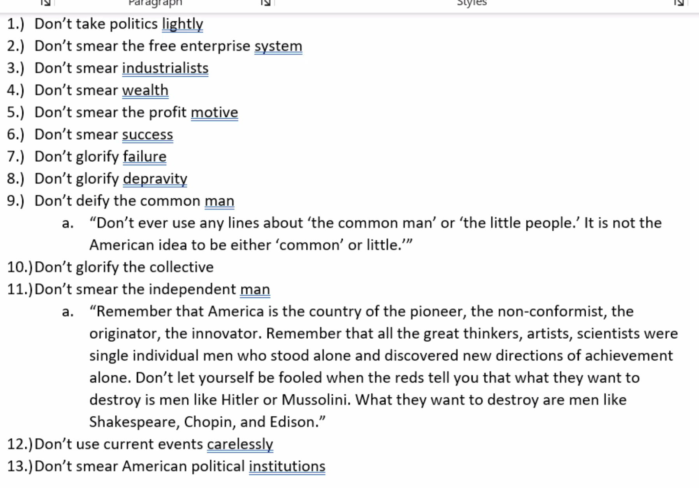

# **Fri [03/24/2023]: Cinematography**

* D. W. Griffith and Billy Bitzer
  + *Birth of a Nation*, pioneered storytelling as a narrative medium (fiction as a genre)
  + Sound and Color
* Studio Era: Studio Styles
  + Harold Rosson (MGM: *Wizard of Oz*, *Singing in the Rain*)
  + Greg Toland (*Best Years of Our Lives*, *Citizen Kane*)
  + James Wong Howe (*Algiers*, *Hud*)
    - First Asian-American film maker to make it big
  + Freddie Young (*Lawrence of Arabia*)
  + Orson Welles (*Citizen Kane* director)
* Film Noir Genre
  + Moods of claustrophobia, paranoia, despair, and nihilism with a worldview that is expressed through the film’s style
  + Usage of low-key rather than high-key lighting (intentionally darker scenes/no effort to beautify scenes with flattering lighting sets)
  + Example: “Claustrophobic” from *A Touch of Evil* is a long famous tracking shot of the Film Noir style
  + TV tries to compete with color
    - Return of “The Epic” style films
    - Russell Metty (*Spartacus*)
      * Grand-scale set design and epic-style shots; lots of people/set pieces
    - Freddie Young (*Lawrence of Arabia*)
      * Shows vastness of desert and similar scenes of grandiose scale/space
* New Hollywood
  + Influenced by French New-Wave films
  + Influx of new ideas, advanced technologies, creative/artistic freedom due to new blood in industry
    - Coppola, Scorsese, etc
  + Mobile Framing
    - Pan Shot: Camera stationary but tilts on vertical axis
    - Tilt Shot: Camera stationary but tilts on horizontal axis
    - Dolly Shot: Camera moves horizontally
    - Crane Shot: Camera moves vertically
    - Mobile Steady Cameras revolutionized film history further (1970s invented)
      * First movie to win using: *Rocky*

# **Fri [03/31/2023]: Power-War Pressures on the Studio System**

* Brief Overview/History
  + Vertical Integration and Consolidation/Control of Studios in 1930s - 1960s
  + Legal Challenges: Antitrust
    - Initial Antitrust Lawsuit (1938)
      * Attacking “block booking” and “blind buying”
      * Consent Decree (1940)
    - Bigelow v RKO (1946)
    - United States v Paramount Pictures (1948)
      * Landmark antitrust decision
      * Vertical Dis-integration: studios forced to divest theater properties
    - Aftermath:
      * Rise of independent studios
      * Curtailing studio production
        + Fewer films made
        + Higher production costs
      * Independent studios
        + New financial relationships
        + Art House theaters
      * Weakening the Code
    - Legal Challenges: Censorship
      * Mutual Film Corp v Industrial Commission of Ohio (1915)
      * Joseph Burstyn, Inc. v Wilson (1952)
        + “Blasphemy Laws”
        + “We conclude that expression by means of motion pictures is included within the free speech and free press guaranty of the First and Fourteenth Amendments”
    - Foreign Challengers:
      * Audience Rebellion
      * Italian Neorealism
      * French New Wave
      * British Invasion
* Breathless Discussion
  + Post WWII traumas
    - Resistance to Tradition
    - Tradition of “Quality”
    - Classical Hollywood Cinema
  + French New Wave Characteristics
    - Faith in Film
    - Low Budget
    - Innovation (Resistance to Convention)
    - Improvisation (content and technique)
    - Location Shooting, Natural Sound
    - Anti-Authoritarianism
  + Cinematic Traditions
    - National Cinemas
      * Emergence/Re-Emergence
      * Engagement with American Film
      * American Awareness
      * Sparks American New-Wave/New Hollywood
      * Counter-Cinema

# **Wed [04/05/2023]: Breathless**

* Making films less realistic and more artificial (French New Wave)
  + Breaking the fourth wall (looking and talking directly at the camera)
  + Lots of jump cuts (with sound bridge)
* Diarrhea trash
* Aggressively trying to throw your sense of space off
  + Jason Vredenburg said he was hit by a truck
  + Scattered scenes correlate to how he recalls the event, similar to Michel’s driving montage
  + Meta film → Film about filmmaking
    - Characters engaging in the process of making the film (Michael imagining himself as a Hollywood actor throughout the film)
    - Michel practices his facial expressions as if he is preparing for a performance (while in the movie performance)
    - Pedestrians turning their heads towards the camera as they walk by
    - Mimicking cinematography throughout the apartment scene (Patricia staging Michel using a rolled up poster in place of a camera)
* Cautionary tale

# **Wed [04/12/2023]: *The Aviator* and *Touch of Evil***

* Final Exam: Wednesday May 10th or Take Home Exam
* Notes on Cinematography:
  + The Aviator
    - The way of the future
    - Clutter: Many scenes are bloated with things going on
      * i.e. Filming Hell’s Angels with all the planes going around
      * i.e. the FBI raid on Howard’s apartment with everything being thrown around
      * Reminiscent of the Copa scene from *Goodfellas* or scenes inside the *Tangiers* in Casino
    - Isolation at the beginning and the end
    - Crashes into an organized field; seems at peace in the first crash
    - Experiential realism: Howard’s breakdowns give a sense of uneasiness
    - Aviator shot used film techniques to imitate visual representation of color-changing technologies
      * Used imitated Bipek system well seen in 1st crash when Howard crashes into the field with very blue coloring
      * Used methods to mimic technicolor in second crash scene, more vibrant colors
    - Florian continuing to add irrelevant information to the conversation in an effort to sound sophisticated
  + Touch of Evil
    - Began empty, then makes a complete 180
    - The Mysterious Ticking noise (it was a pipe bomb)
    - First scene is a really long take of the main characters walking continuously in Mexico City. Bomb is planted at B site (random car) and the camera continues to follow car and then Mr. and Mrs. Vargas as they walk and drive towards checkpoint
      * Car is always in frame to remind viewers that the bomb is still there, but focuses on the Vargas’ as they walk and interact with people on the street
    - I am inspired to blow something up
    - Mexico was not yellow wtf
    - 

# **Wed [04/28/2023]: *The Independent Cinema?***

* The Original Independents
* Resistance to the Studio System
  + United Artists (1919)
  + Society of Independent Motion Pictures (1941)
    - Legal Challenges to Studio System
  + Avant-Garde and Experimental Films
    - Alternative Approach to film as “art”
      * Key Figures:
        + Maya Deren (Meshes of the Afternoon)
        + Kenneth Anger (Fireworks)
        + Stan Brakhage (Mothlight)
        + Bruce Baillie (All My Life)
  + Independent Directors in the 1950s:
    - Stanley Kubrick
    - Robert Altman
    - Morris Engel, Ruth Orton, and Ray Abrashkin